13 November 2018

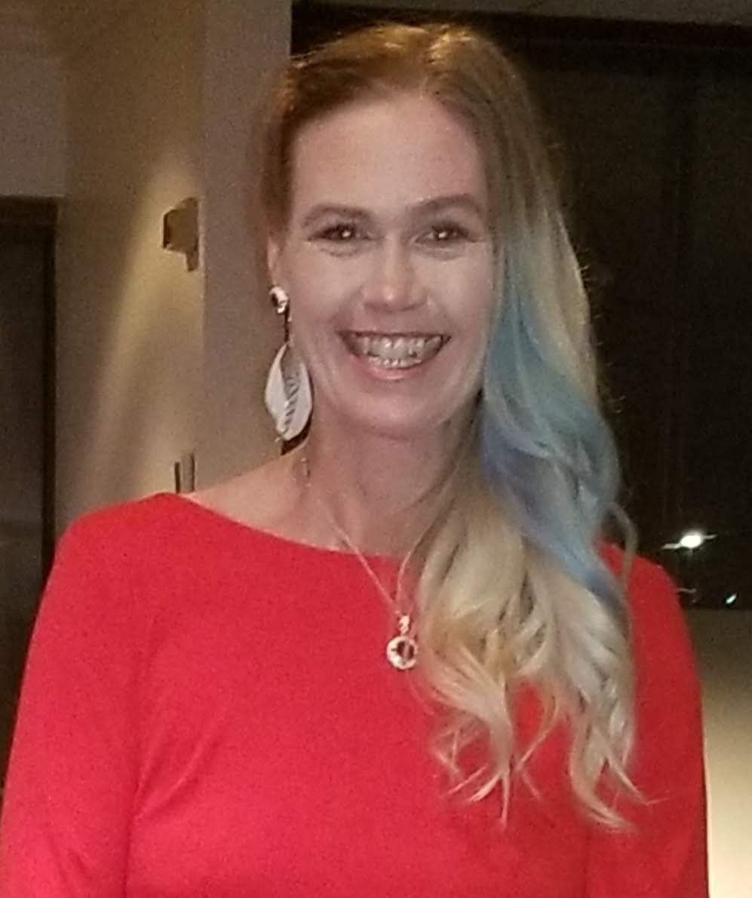

Dawn McIlmoyle, BScN, RN

Veteran and Abuse Advocate

# Objective

To educate, raise awareness and prevent abuse of Veterans, Civilians and Children. To show perseverance and positivity can prevail.

## Education

### Trent university, peterborough, ontario

I completed a Bachelor of Science in Nursing while raising two boys alone and working full time. I have also re-enrolled into an Indigenous Studies degree part time.

## Vitals

302 Kitchener Ave

Oshawa, ON L1H 3B5

**T** (705) 772-1903

**E** dawnmcilmoyle@gmail.com

Dear Recipient:

I believe strongly that to change the future we must intercede in the conditioning and challenges faced in Society today and raise our voices for change. Trauma is a part of life in many ways, however the ability to move on is often lost or is not taught.

I have an incredible amount of knowledge about domestic violence, child abuse, alcoholism, military sexual trauma, PTSD, Veteran issues, Women issues, gender discrimination, cannabis, and health related issues.

I truly believe that no matter what someone has gone through, witnessed or had done to them they can still do or accomplish anything they want to.

I am offering my Services to give seminars or presentations to all age groups regarding any of these subjects in a positive manner and am extremely adaptable to any audience.

As one of the first Women to come forward about abuse in the Military I feel that change is imminent and now is the time to educate our Nation about how to create positive change from truly devastating conditions and rebuild.

Sincerely,

Dawn McIlmoyle, BScN, RN